**Physics Ordinary Level 2024**

**1.**

A student carried out an experiment to investigate the laws of equilibrium. He suspended a metre stick from two Newton spring balances and hung two weights from the metre stick, as outlined in the tables below, until it was balanced and level.

Before setting up the experiment, the student took two measurements. He measured the weight of the metre stick to be 3 N.

He found its centre of gravity at the 50 cm mark.

His results are shown in the tables below.

|  |  |  |
| --- | --- | --- |
| Newton Spring Balances | | |
| *Upward forces* (N) | 6 | 4 |
| *Position* (cm) | 20 | 70 |

|  |  |  |
| --- | --- | --- |
| Weights | | |
| *Downward forces* (N) | 5 | 2 |
| *Position* (cm) | 26 | 60 |

1. How did the student measure the weight of the metre stick?
2. Describe how he found the centre of gravity of the metre stick.
3. Copy the diagram of the metre stick below into your answerbook.

Two of the forces have been included.

Complete your diagram to show all upward and downward forces and their positions.

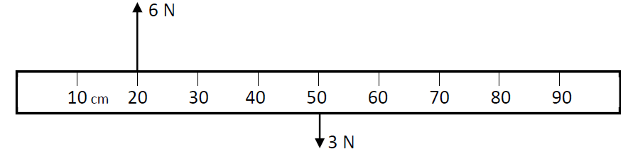

1. The first law of equilibrium states that the sum of the upward forces equals the sum of the downward forces.

Use the data to show that the first law of equilibrium is verified in this experiment.

1. The second law of equilibrium states that the sum of the clockwise moments equals the sum of the anticlockwise moments. (Remember: Moment = Force × Distance)

Use the data to calculate the clockwise moments on the metre stick about the 0 cm mark.

1. Use the data to calculate the anticlockwise moments on the metre stick about the 0 cm mark.
2. Use your calculations to show that the second law of equilibrium is verified in this experiment.

**2.**

A student carried out an experiment to measure *f*, the focal length of a converging lens.

1. Draw a labelled diagram of the arrangement of the apparatus used in this experiment.
2. On your diagram, indicate and label the object distance *u* and the image distance *v*.
3. The student ensured that the object was placed outside the focal length of the lens.

Explain why the student had to place the object outside the focal length of the lens.

1. How did the student know that the correct image distance had been found?

|  |  |  |  |
| --- | --- | --- | --- |
| *u* (cm) | 18 | 25 | 30 |
| *v* (cm) | 90 | 38 | 30 |
|  |  |  |  |

The following results were recorded.

1. Using the *Formulae and Tables* booklet, write the lens formula used to calculate *f*.
2. Use the formula and the data in the table to calculate *f*.

**3.**

A student carried out an experiment to measure *cwater*, the specific heat capacity of water.

She added heat energy Δ*E* to water in a copper calorimeter.

The following results were recorded.

Mass of empty copper calorimeter, *mcalorimeter* = 0.106 kg

Mass of calorimeter and cold water = 0.262 kg

Initial temperature of cold water and calorimeter = 18 °C

Final temperature of water and calorimeter = 23 °C

Heat energy added, Δ*E* = 3467 J

1. Draw a labelled diagram of the apparatus used in this experiment.
2. How did the student supply the heat energy needed to increase the temperature of the water and the calorimeter?
3. Calculate **A**, the mass of the water *mwater*.
4. Calculate **B**, the increase in temperature of the calorimeter and the cold water.
5. Using your answers for **A** and **B**, and given that the specific heat capacity of copper

*ccopper* = 390 J kg–1 K–1, complete the following calculations and find a value of *cwater*.

Heat energy added = Heat gained by water and calorimeter

Δ*E* = *mwatercwaterΔϴwater* + *mcalorimeterccopperΔϴcalorimeter*

3467 = **A** × *cwater* × **B** + 0.106 × 390 × **B**

4.

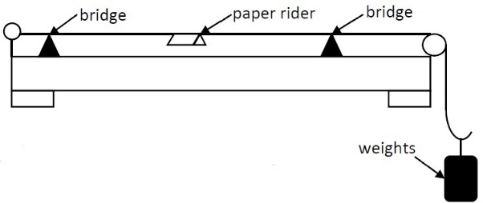A student carried out an experiment to investigate how the fundamental frequency *f* of a stretched string changes with length *l*. The student set a length of string vibrating and adjusted the length until resonance occurred. The tension of the string was kept constant throughout the experiment.

On the right is a diagram of the apparatus used in this experiment.

1. How did the student set the string vibrating?
2. Describe what length *l* of string the student could measure.
3. Explain why the tension of the string was kept constant.
4. What was the function of the paper rider?

The student recorded the following results.

|  |  |  |  |  |  |  |
| --- | --- | --- | --- | --- | --- | --- |
| *f* (Hz) | 256 | 320 | 341 | 427 | 480 | 512 |
| *l* (m) | 0.214 | 0.171 | 0.160 | 0.127 | 0.114 | 0.107 |
| 1/*l* (m-1) | 4.67 | 5.85 |  |  |  |  |

1. Copy and complete the table above into your answerbook by calculating the value of 1/*l* to 2 decimal places.
2. Use the data to plot a graph of 1/*l* against *f.*

**5.**

A student carried out an experiment to investigate how the resistance *R* of a metallic conductor changes with temperature *T*.

1. Draw a labelled diagram of the arrangement of the apparatus used in this experiment.
2. How did the student vary the temperature of the metallic conductor?
3. State one safety precaution that the student should have taken. (22)

|  |  |  |  |  |  |  |
| --- | --- | --- | --- | --- | --- | --- |
| *T* (°C) | 10 | 20 | 30 | 40 | 50 | 60 |
| *R* (Ω) | 5.2 | 5.9 | 6.5 | 7.2 | 7.9 | 8.5 |

The student recorded the following data.

1. Use the data to plot a graph to show the relationship between *T* and *R*.
2. Describe the relationship between *T* and *R*.
3. The student used the apparatus to estimate the temperature of an unknown liquid.

The resistance was measured as 5.5 Ω.

Use your graph to estimate the temperature of the unknown liquid.

**SECTION B (280 MARKS)**

Answer **five** questions from this section.

Each question carries 56 marks.

**6.** Answer any **eight** of the following parts (*a*), (*b*), (*c*), etc.

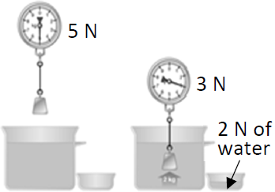

1. State the principle of conservation of momentum.
2. What is the difference between a scalar quantity and a vector quantity?
3. Explain Archimedes’ principle.

*The diagram on the right may help your answer.*

1. Describe an experiment to compare the rates of conduction of heat through different solids.
2. State one difference between light waves and sound waves.
3. The Doppler effect is used in a radar system to detect the speed of cars. What is the Doppler effect?  
   *A labelled diagram may help you answer.*
4. The solar constant (solar irradiance) is a measure of how much radiation from the Sun falls on each square metre of the Earth’s atmosphere in one second.

It has a value of 1.36 kW m−2.   
Calculate the amount of energy falling per second on an area of 72 m2.

1. What is meant by capacitance?
2. State a safety precaution that should be taken when working with radioactive materials.
3. The critical angle of diamond is 24.4°. Calculate *n*, the refractive index of the diamond.
4. Name one part of the eye. Explain its function.
5. Draw the magnetic field around a bar magnet.

**7.**

Oleksii Novikov from Ukraine broke the world record in 2020 in the deadlift.

He achieved the world record by lifting a mass of 537.5 kg from the ground to a height of 46 cm.

1. Explain the difference between mass and weight.
2. Calculate the weight of a 537.5 kg mass.
3. Calculate the work done in lifting this weight from the ground to a height of 46 cm.
4. To successfully complete the deadlift, a lifter has to bring the bar to a height of 46 cm and then wait for the referee to signal that the bar can be lowered to the ground.

Draw a diagram of the forces acting on the bar when it is held at a height of 46 cm.

In 2020, Novikov won the World’s Strongest Man competition.

One of the events in this competition is a bus pull. The bus has a mass of 19 000 kg.

1. Momentum is important when moving the bus. What is meant by momentum?
2. Calculate the momentum of the bus when its speed is 0.6 m s–1.

Include units in your answer.

1. It took one man 52 s to complete the course.   
   The bus started at rest. It took him 5 s to get the bus to a top speed of 0.6 m s–1.   
   The bus maintained that speed for 46 s and then it took 1 s for the bus to roll to a stop.

Suggest a reason that the bus rolled to a stop.

1. Draw a velocity–time graph for the motion of the bus during the 52 s.

*acceleration due to gravity g = 9.8 m s*–*2*

**8.**

Light can be reflected by many different surfaces.

The picture on the right shows light being reflected from a plane mirror. An image is formed.

1. Explain what is meant by an image.
2. State one property of the image produced by a plane mirror.
3. State one use of a plane mirror.
4. One of the laws of reflection of light states that the angle of incidence equals the angle of reflection.

Describe an experiment to demonstrate this law of reflection.

1. Light is also reflected from curved mirrors.

In your answerbook, copy and complete the ray diagram below to show how a magnified image is formed in a concave mirror.

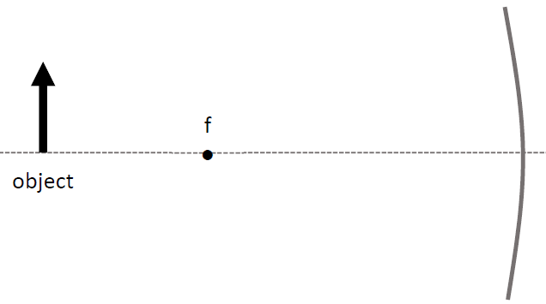

1. 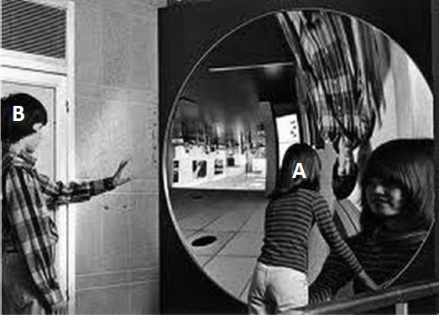The picture on the right shows images in a concave mirror.

Explain why the image of person **A** in the picture on the right is upright but the image of person **B** is upside down.

1. An object is placed 20 cm in front of a concave mirror and the image is formed 40 cm in front of the mirror.

Calculate the magnification *m* of this image.

1. If the object is 5 cm high, calculate the height of the image.

**9.**

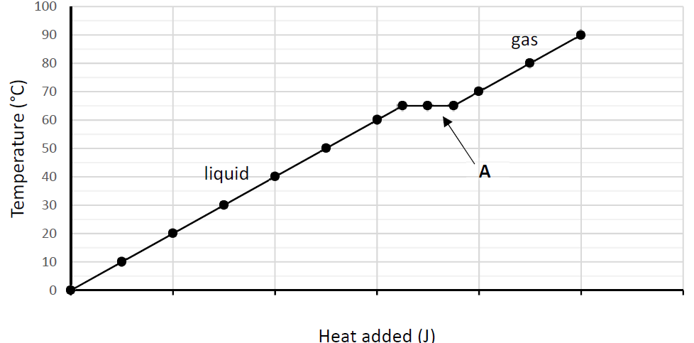Solids, liquids and gases can change state when they are heated or cooled.

A heat pump is a device used in household freezers. It consists of a closed system of circulating fluid called a refrigerant which absorbs and releases latent heat as it changes state.

The graph shows the temperature of a substance as heat is added and it changes state from a liquid to a gas.

1. What is meant by latent heat?
2. Explain why the graph flattens out at **A**.
3. The specific latent heat of vaporisation of the refrigerant is 141 100 J kg–1.

Calculate the heat energy needed to change 0.3 kg of refrigerant from liquid to gas.

1. What happens to the temperature inside a freezer when the liquid changes state to become a gas?
2. The heat pump also turns the gas back into a liquid.

According to the graph, what temperature does this happen at?

1. What is the process called when a gas changes into a liquid?
2. Draw a labelled diagram of a heat pump.
3. The temperature of the refrigerant can be measured using a thermometer.

Different thermometers are based on different thermometric properties.

What is meant by a thermometric property?

1. What is the thermometric property of an alcohol-in-glass thermometer?
2. State one everyday use of a thermometer.

**10.**

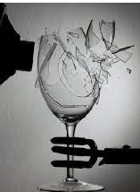When a person sings, their vocal chords vibrate. This vibration can cause a wine glass to shatter if resonance occurs.

1. What is meant by resonance?
2. Describe a laboratory experiment to demonstrate resonance.

A clarinet is an instrument that can be thought of as a pipe closed at one end.

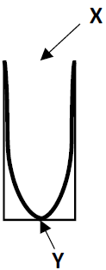

1. The diagram on the right shows a sound wave vibrating at its fundamental frequency in a pipe closed at one end.   
   Name the parts of the stationary wave labelled **X** and **Y**.
2. Draw a diagram, in your answerbook, to show the next harmonic for a sound wave in the same pipe.
3. The speed of sound in air *c* is 336 m s–1 and the frequency *f* of the wave is 320 Hz.   
   Calculate the wavelength *λ* of the sound wave.
4. The distance from **X** to **Y** is taken as $λ/4$. Calculate the length of the pipe.
5. If a musician increases the loudness of the note she plays, she has increased the amplitude of the sound wave.

What property of the wave needs to change to affect the pitch of the note?

A flute is an instrument that can be thought of as a pipe that is open at both ends.

1. Draw a diagram to show a sound wave vibrating at its fundamental frequency in a pipe open at both ends.
2. A sound wave vibrates at its fundamental frequency in a pipe of length 60 cm which is open at both ends. Calculate the wavelength of the sound wave.

**11**.

Electric current is the movement of charged particles through a conductor.

1. 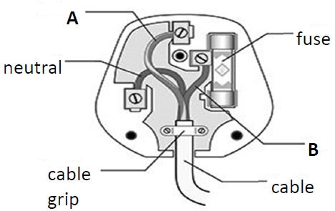State an example of an electrical conductor.
2. Name an instrument used to measure electric current.
3. The diagram on the right shows the parts of an electrical plug. Name the wires labelled **A** and **B**.
4. A fuse is used as a safety precaution.

Describe how a fuse works.

1. A miniature circuit breaker (MCB) is another device used for safety.

What is an advantage of using a MCB instead of a fuse in a domestic circuit?

1. 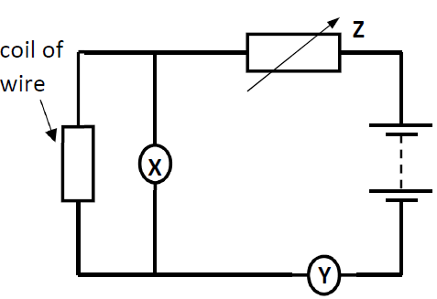Name another safety feature used in domestic circuits.
2. The circuit below is used in an experiment to demonstrate Ohm’s law.

Which of the devices, **X** or **Y** is a voltmeter?

Explain your answer.

1. The electrical component **Z** is a variable resistor.

Explain why a variable resistor is used in the circuit when demonstrating Ohm’s law.

1. Previous results from the experiment have shown the resistance of the coil of wire is 2.5 Ω.

Verify that the resistance is 2.5 Ω by calculating the resistance *R* when the voltage *V* is 2 V and the current *I* is 0.8 A.

1. The resistance of the coil of wire is 2.5 Ω and the resistance of device **X** is 20 000 Ω.

Calculate the total resistance of this parallel combination.

**12.**

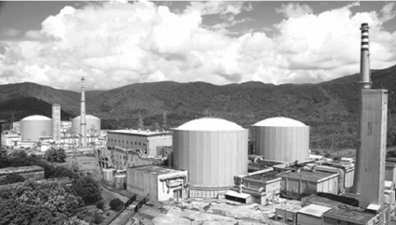The picture on the right is a nuclear fission reactor in Kamataka, a state in India.

1. What is meant by nuclear fission?
2. The control rods and the moderator play a very important role in the production of energy by nuclear fission.

Explain the function of (*a*) the control rods, (*b*) the moderator.

1. The fission reactor must also have a shield.   
   What material could be used to make the shield?
2. The fuels typically used in a nuclear fission reactor are isotopes of plutonium and uranium.

What are isotopes?

1. Pu–239 is an isotope of plutonium. It has a half-life of 24 110 years.

What fraction of the isotope will remain after 72 330 years?

1. When Pu–239 decays, it emits alpha particles $α_{2}^{4}$.

What is the daughter nucleus **X** in the nuclear reaction below when an atom of ${Pu}_{94}^{239}$ emits $α_{2}^{4}$?

${Pu}_{94}^{239}$ $→$ X + $α_{2}^{4}$

When uranium undergoes nuclear fission, neutrons are produced in the reaction.

These help sustain a chain reaction. Neutrons are sub-atomic particles.

1. Draw a diagram of an atom and indicate where the neutrons are located.
2. Name another sub-atomic particle.
3. Nuclear fusion is another type of nuclear reaction.

What is meant by nuclear fusion?

1. State one advantage of a nuclear fusion reactor over a nuclear fission reactor.

**13.**

Read the following passage and answer the questions below.

Every year astronauts go to the International Space

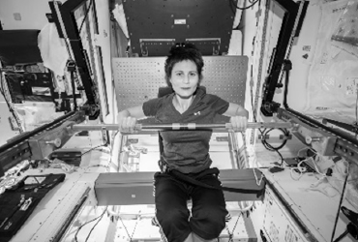Station (ISS). They have to live and work in microgravity for months. The ISS orbits at an altitude of 322 km. It completes one revolution of the Earth every 90 minutes.

At this altitude, acceleration due to gravity is about 90% of what it is on the Earth’s surface.

A big problem with this environment is loss of bone mass. Bones grow and change to adapt to your body's needs. In microgravity, the breaking down of bones happens faster than the rebuilding. This is because bones adapt to this new environment where they don't have to carry the body’s weight due to the reduced gravity. Astronauts may be more likely to fracture their bones later in life. Because of this issue, astronauts spend a lot of their time in space doing exercise.

The leg and arm bones of 17 astronauts before and after spaceflight were examined. A computed tomography (CT) scanner was used which provided high resolution 3D images.

The bones were examined for thickness, strength and density. The goal was to understand the role of exercising before and during spaceflight.

Adapted from: www.ScienceJournalForKids.org

1. How high above the Earth is the ISS?
2. How many full orbits of the Earth does the ISS make in 24 hours?
3. Describe how acceleration due to gravity changes as the distance from the centre of the Earth increases.
4. A CT scanner uses X-rays to produce images of the inside of the body.

What are X-rays?

1. Draw a labelled diagram of an X-ray tube.
2. The bone density of an astronaut was 1.39 g cm–3 before leaving Earth.

The total volume of her bones is 7140 cm3. Calculate the total mass of her bones at that time.

1. The temperature outside the ISS is 116 K. Convert this temperature to Celsius (°C).
2. Why do astronauts spend a lot of their time doing exercise while on the ISS?

**14.**

Answer any **two** of the following parts (*a*), (*b*), (*c*), (*d*).

(*a*)

Newton’s three laws of motion describe the relationship between the motion of an object and the forces acting on it.

A 1900 kg car is moving at 20 m s–1 to the right on a horizontal road. It has balanced forces acting on it in opposite directions as shown.

1. Calculate the net horizontal force acting on the car.
2. What is the acceleration of the car?
3. What is the velocity of the car 12 s later?
4. State Newton’s first law of motion.

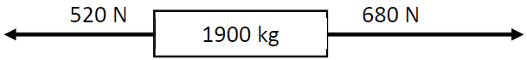Newton’s second law of motion states that the rate of change of momentum of an object is proportional to the net force applied to it.

The same car is still moving at 20 m s–1 to the right but it now has unbalanced forces acting on it as shown.

1. Calculate the net horizontal force acting on the car.
2. Calculate the acceleration of the car.
3. Calculate the velocity of the car after 12 s when the unbalanced forces are acting on the car.

(*b*)

A thermistor is a type of resistor made of semiconductor material whose resistance is dependent on temperature.

1. Name an instrument used to measure resistance.
2. Sketch a graph to show the relationship between resistance and temperature for a thermistor.
3. A thermistor is a semiconductor. What is meant by a semiconductor?

(*a*) Draw a circuit diagram to show a semiconductor diode connected in series with a filament bulb.

(*b*) Indicate if the bulb is lighting or not.

Note: You may refer to the electrical circuit symbols on pages 72 to 78 of the *Formulae and Tables* booklet when answering part (*iv*).

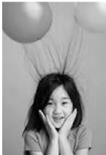(*c*)

A laser light is shone at right angles to a diffraction grating as shown in the diagram below.

Diffraction occurs at the grating producing an interference pattern which can be seen on the screen.

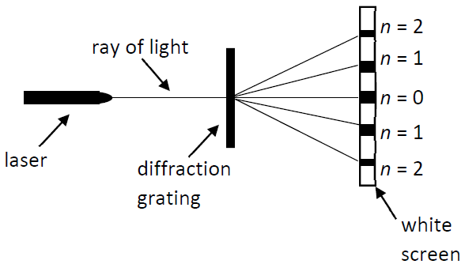

1. What is meant by diffraction?
2. Constructive and destructive interference occurs to produce the interference pattern on the screen.

Distinguish between constructive and destructive interference.

1. The diffraction grating has a grating constant *d* of 2.5 × 10–6 m.

The first order diffracted image (*n* = 1) is at an angle *θ* of 14.6° from the straight through position.

Using the formula *n λ* = *d* sin *θ*, calculate the wavelength *λ* of the laser light.

1. When white light is passed through the diffraction grating, it is split into its constituent colours.

Name the 3 primary colours of light.

1. Name a pair of complementary colours of light.



(*d*)

Objects with opposite charges attract each other and objects with the same charge repel each other.

1. Describe how an object can become charged by contact.
2. Describe an experiment to show that opposite charges attract and like charges repel.

An object becomes charged when it gains or loses electrons.

1. What type of charge does an electron have?
2. 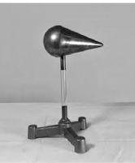Has a positively charged object gained or lost electrons?
3. A student performed an experiment to investigate how charge is distributed on a pear-shaped conductor.

Draw a diagram to show how charge is distributed on a pear-shaped conductor.